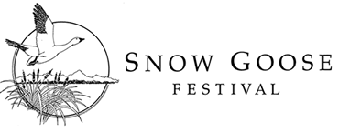
2017 EXHIBITOR APPLICATION FORM

Important: Exhibit days are Saturday – Sunday, January 28-29, 2017 at the Chico Masonic Family Center, Chico, CA. Please read 2017 Snow Goose Festival Exhibitor Guidelines before submitting this form.

Organization Name:
Contact Person:
Address:
City/State/Zip: _______________________________ E-Mail:
Phone: _____________________________ Cell phone:
Webpage:
Character of Exhibit:

Type of Exhibit: We will have a 6’ X 30” table available for your exhibit. Space assignment will be made by exhibit coordinators based on the information that you provide. (check all that apply):

 | Table top exhibit (fits on 6’ or smaller table) |  | Table top exhibit requiring greater than 6’ table (please explain below) |  | Free-standing floor exhibit (no table required)
 | Exhibit has displays on both sides |  | Electricity required |  | Need to be against a wall (please list reason below)

Special Needs:
We would like to have someone at your exhibit to answer questions from 9 am - 4 pm on Saturday and Sunday from 9 am – 3 pm. Will there be someone present? Yes_____ No______

Exhibitor fees:
 | $45 |  | Sponsor (Tundra Swan or higher sponsorship level)
Please sign below. send payment and completed registration form to:
Snow Goose Festival  P.O. Box 1063  Chico, CA 95927 |  | Payment may be made by check, VISA or Mastercard.  Credit Card:  Name on Card:  Card #:  Expiration: _________________ 3 digit code:

Authorized signature _____________________________ Date:

